

Software Engineering Department
Braude College
Capstone Project Phase A – 61998

Error Detection Monitoring as seen by Post Error Slowing using a Mobile App

Project ID: 23-2-R3

Supervisor: Dr. Anat Dahan
Tal Cohen 313394066, tal.cohen@e.braude.ac.il
Koral Ben David Jacob 316540012, koral.ben.david.jaco@e.braude.ac.il

Content
Abstract ……………………………………… 3
1. INTRODUCTION …………………………….. 3
2. BACKGROUND AND RELATED WORK 4
2.1 Error Detection Monitoring 4
2.2 Post Error Slowing 4
2.3 Common Error Monitoring Methods 4
2.4 Brain Activity and Cognitive Error Monitoring 5
2.5 ADHD and Error Detection 5
2.6 EEG 6
2.7 Cognitive and Motor Errors 7
2.8 Kinematic Movement Measurement 7
2.9 Movement speed Metric 8
2.10 Movement accuracy Metric 8
2.11 Movement smoothness Metric 9
3. Expected Achievements …………………. 9
4. Research / Engineering Process 9
4.1 Research – Post Error Slowing and Error Detection Monitoring 10
4.2 Research – General Description of the Task 10
5. Product …………………………………….. 13
5.1 Development Environment 13
5.2 Database 14
5.3 Log Files 14
5.4 Analysis of Results 14
6. GUI …………………………………………….. 16
7. Evaluation/Verification Plan 16
7.1 Evaluation 21
7.2 Verification-Testing Plan 21
REFERENCES ……………………………………. 24

Abstract
In this project, we aim to develop an interactive mobile application for testing post-error slowing exhibited in motor movement and actions.
Post-error slowing (PES) is a phenomenon in which a person exhibits a slowdown in his reaction times in performing motor actions that followed an error. It is related to brain processes that relate to monitoring our behavior, and to our ability as humans to recognize mistakes. This phenomena is related to cognitive processes that occur by adjusting our behavior and movement to reduce the probability that such mistakes will happen again.
The primary objective of this research project is to investigate the relationship between Post-Error Slowing and individuals with ADHD. Our aim is to enhance our understanding of the post-error slowing phenomenon. To achieve this, we will develop an application that presents users with an interactive task, where errors occur in an artificial and controlled manner. As users engage in the task, we will gather kinematic data for analysis. By analyzing the collected data, we will measure error recognition for different errors and quantify error thresholds (the point at which the user recognizes an error) and assess their ability to correct mistakes.
Keywords: Error Detection Monitoring, Post-Error Slowing, ADHD, Mobile App, Task, PES, Kinematic Movement.

1. INTRODUCTION
Monitoring and adjusting our performance are crucial for adaptive behavior. It is a key component of human cognitive control. One widely studied metric of this behavior is post-error slowing (PES), the finding that humans tend to slow down their performance after making an error.
Motor errors can stem from a variety of factors, such as, lack of motor planning, coordination, deficiencies in sensory feedback, wrong timing, mistakes in judging spatial distances.
There are various methods used to quantify and analyze an individual’s ability to monitor and detect errors, or if PES occurred. Tasks such as ‘Flanker Task’ and ‘Stroop Task’ are two widely used tasks in studies around the world.
ADHD is a common disorder, and those who suffer from it, present one or more of the following symptoms: inattention, hyperactivity, and impulsivity. Studies showed that there is a direct link between ADHD and error detection monitoring. ADHD limits the ability to detect, monitor, and correct errors.
Our motivation is to solidify the connection between ADHD and Error Detection monitoring, focusing on Motoric and Kinematic errors. By researching post-Error slowing phenomenon presented by people with and without ADHD, finding a strong connection may even allow for the development of a tool that will help with diagnosing ADHD over time.
We strive to create a tool that will present users with a task that they will perform. Our tool will analyze data input collected from the user whilst performing the task. Specifically, our tool will analyze motoric movement and kinematic changes presented by the user and will help quantify and evaluate the differences in error detection and post-error slowing in people with and without ADHD.
The rest of the document will present a more in-depth view of former methods used in analyzing error detection monitoring and post-error slowing, the mathematical metrics developed to measure kinematic and motoric changes and errors, and what metrics we will use in our tool.

2. BACKGROUND AND RELATED WORK

2.1 Error Detection Monitoring
Error detection monitoring in humans refers to the cognitive process by which individuals can identify and detect errors or mistakes in their actions, or behavior. It involves the ability to self-monitor and recognize when something is incorrect, inaccurate, or inconsistent with one's intentions or goals. It can occur in various cognitive domains, including perception, memory, language, decision-making, and motor skills ^{[2]}.
Detecting and monitoring our mistakes is an important cognitive process that allows humans to correct errors, learn from mistakes, and improve their performance and accuracy over time. It is a fundamental aspect of human cognition and plays a critical role in tasks that require accuracy, precision, and goal-directed behavior, such as problem-solving, decision-making, and skilled performance ^{[2]}.

2.2 Post Error Slowing
Post-error slowing is a cognitive phenomenon where individuals tend to exhibit slower response times and more careful behavior and actions following an error or mistake on a task. It is a measure of how the brain and cognitive systems respond to errors and adjust our behavior accordingly to reduce the probability of performing such errors or mistakes again ^{[1]}

2.3 Common Error Monitoring Methods
Stroop Task is a commonly used method of monitoring and analyzing Post Error Slowing. In this task test participants are presented with words describing colors (e.g., the word "red" or "green") but these words are printed in incongruent ink colors (e.g., the word "green" written with blue ink). The participants must name the ink color or the word color while ignoring the incongruent part. Errors are created by presenting conflicting word meanings and ink. We measure PES (Post Error Slowing) by calculating the difference in response times (RTs) between correct trials and error trials (trials that intentionally presented conflicting meanings) ^{[2,3]}.
Another common task is the Flanker Task. In this task, participants are instructed to focus on a central target stimulus that is flanked by distracting stimuli. e.g., a string of letters "HHSSHSHH" is presented to the user, and 'H' represents pressing the left arrow and 'S' the right arrow in the keyboard the user must press 'S' and discard other letters (stimuli) ^{[2,4]}. Errors are created by presenting distractors stimuli opposite to the central stimuli. PES is measured by analyzing the difference in response times between correct trials where errors occurred and correct trials without errors occurring in them ^{[2,4]}.

2.4 Brain Activity and Cognitive Error Monitoring
Studies have shown that while making a mistake or an error there are certain regions in the brain that respond to those mistakes and affect the cognitive actions afterward.
The posterior Medial Frontal Cortex (pMFC) is assumed to monitor performance problems. It oversees interaction with other regions in the brain after a conflict (problem, mistake) occurred. Once a conflict occurred the pMFC interacts with various perceptual and cognitive regions and shifts the attentional focus towards the relevant task and the information needed for it. If needed it will also induce motor adaptations. These adaptations are in fact post-error slowing ^{[5]}.
Another region in the brain that responds to errors or conflicts and affects cognitive actions is the ACC (Anterior Cingulate Cortex). Studies showed that this region has strong activity once an error has occurred which also affects cognitive control and reaction ^{[2,8]}.

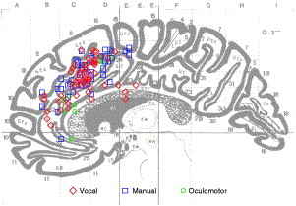
Figure 1: Region activation from imaging studies involving conflicts. Color coding refers to the model of response in the monitoring task (red-vocal, blue-manual, green-oculomotor) ^{[2]}

2.5 ADHD and Error Detection
Attention Deficit Hyperactivity Disorder (ADHD) is a common mental disorder that interferes with day-to-day activities. It is usually first diagnosed in childhood but also in adulthood. ADHD symptoms include inattention, hyperactivity, and impulsivity. These symptoms can change over time as a person ages.
Studies among children and adults showed that people with ADHD have a limitation in their ability to detect and monitor errors. In addition, they are limited in their ability to slow down if needed to reduce the number of errors that occurred or adapt to said errors ^{[6,7]}.

2.6 EEG
EEG (Electroencephalogram) is a non-invasive neurophysiological technique used to measure and record the electrical activity of the brain. During an EEG recording session, electrodes are attached to the scalp of the subject, and act as sensors that pick up the electrical signals generated by the brain [Fig 2].
Human brain cells communicate through electrical impulses and an EEG recording presents the brain activity as "EEG Waveforms" (brainwaves) [Fig 3]. These waves are classified into different frequency bands associated with different brain activity states. They are also linked to various cognitive processes. EEG's ability to detect and present changes in brain activity helps with diagnosing brain damage or dysfunctions. (e.g., sleep disorders, stroke, cognitive dysfunction, etc.)
In addition to the raw EEG signals, there are more signals associated with error detection. These signals are called 'Event-related potentials' (ERPs). ERPs are electrical signals that are embodied within the raw EEG waveform signals, and they appear because of an event that triggered it.
Within ERPs there is a special Event-related signal that is associated specifically with errors, and it's called an 'Error-related potential' (ErrP) [Fig 4] ^{[11,12]}.
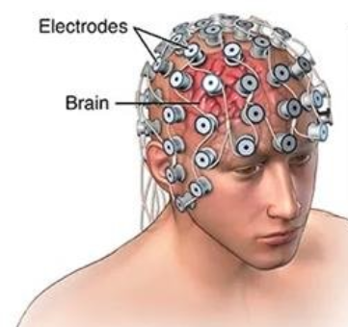
Figure 2: Electrodes connected to the scalp in an EEG test. ^{[9]}
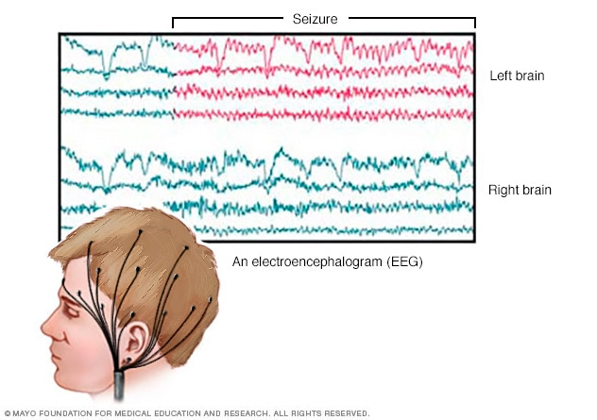
Figure 3: "EEG brain activity" and wave forms. ^{[9]}
Figure 4: ErrP signal in the brain. ^{[11]}

2.7 Cognitive and Motor Errors
Cognitive and Motor errors are mistakes or inaccuracies that occur in cognitive processes and comprehension, and motor actions. These errors may occur due to various factors. Some common errors are:
Cognitive:
Perceptual and Contextual Errors: Occur when the brain distorts sensory information. E.g., mistaking an object to be a different one or misperceiving sizes or shapes.
Attentional Errors: This may happen when there is a lapse and/or lack of attention, or even over-attention while performing tasks ^{[10]}.
Motor:
- Execution Errors: Occur during the execution of motor actions. These errors may involve inaccurate movement, lack of coordination, timing issues, and unsubtle or sudden motoric actions.
- Planning and Decision-Making Errors: These errors happen due to deficiencies in the formulation or organization process of motor actions. Such errors may lead to inefficiency in performing simple or complicated tasks ^{[10]}, difficulty with sequencing and prioritizing motor actions and more.

2.8 Kinematic Movement Measurement
The ability to quantitatively measure human movement is important for our understanding of the kinematics involved in such movement ^{[13]}.
Focusing on the upper extremity movements, clinical scale classifications have classified these movements into two main categories, functional movements, and activities of daily living (ADL) ^{[14]}.
Movement-related metrics and profiles ^{[14,15]} (kinematic metrics) were proposed and studied before. Each metric is used to examine specific aspects of the motor or movement characteristics and are used to quantify kinematic movement ^{[14]}.

2.9 Movement speed Metric
Movement time – a measure of the time required to finish a functional task successfully. This measurement can also be calculated in phases/segments in the tasks ^{[14]}. (e.g., 1. Reaching for the object, 2. Stabilizing the object in the hand.)
Maximum and Mean Velocity – measurements of the velocity of the arm/object moved by the subject ^{[14]}. One aspect of measurement showcased that people with dysfunctions in motor movement or disorders such as ADHD have several peaks and noises [Fig 5] in their hand velocity profiles ^{[14,15]}.
Figure 5: " An example of the differences of velocity profiles of a reaching movement for subjects with (left graph) and without ADHD (right graph). " ^{[15]}

2.10 Movement accuracy Metric
Movement deviation – a measure of movement quality. The quality is calculated in terms of the deviation presented by the subjects from a desired trajectory. The deviation metric is "considered a measure of the error in accuracy" ^{[14]}.
Target Error – measures the movement quality in terms of accuracy regarding the endpoint error (as mentioned in the literature). Endpoint error is the error calculated around the distance of the target placement from the user placement at the end of the movement ^{[14]}.
Spatial overshoot – is "a measure of the spatial excess in any direction of the movement" ^{[14]}. We consider it to be the spatial excess outside the limits and boundaries we described.

2.11 Movement smoothness Metric
Ratio between mean (average) and maximum velocity – this ratio measures the quality of movement in terms of its smoothness. Subjects with movement disorders may present alterations during their movement patterns with relation to acceleration and deceleration, sharp and/or brisk movements. This metric could detect such alterations in movement ^{[14,15]}.
Number of velocity peaks – it is computed from the speed profile of the movement that was presented by the subject. Subjects with normal reaching movements will present only one velocity peak while with the presence of movement disorders smoothness of the motion deteriorates [Fig 5], resulting in more velocity peaks ^{[14,15]}.
Mean arrest period ratio – this metric is related to the number of unnecessary stops done in the time frame of the movement performed toward an objective. When such movement is performed several stops usually occur in its timeframe. People with movement disorders present a greater number of stops which causes the movement to be less smooth. "This metric has been computed as the ratio between the movement time in which the hand stops and the total movement time. The hand was considered “stopped” if the hand velocity was less than 20% of the mean velocity during the movement analyzed." ^{[14]}
Jerk – the rate of change in a subject's acceleration profile during movement is represented by the Jerk metric. This measure is computed from the 3rd time derivative of the position vector during the hand movement, or, as the 2nd time derivative of the velocity vector of said movement. This metric measures the non-smoothness quality in the movement ^{[14,15]}.

3. Expected Achievements
We expect to create a tool / system that will help us to understand and solidify the connection between Post Error Slowing, Error detection monitoring and ADHD. Our tool will simulate a task to the users and whilst doing it, we will collect relevant data and analyze it afterwards.
We would define success if the metrics collected and analyzed (velocity vectors and peaks, jerk smoothness metric, angle positioning, etc.) will have significant differentials from “healthy” (without ADHD) test subjects.
Moreover, we strive to build an app with good and intuitive UI, and graphical visualization of data (charts, graphs) so that it will be of use for any researcher.

4. Research / Engineering Process
The learning and research process until now combined theoretical study about what motor errors and post-error slowing are, including detection and correction of said errors, ADHD. We conducted technological research as well with consideration on how we can create a platform or a tool that will help us collect and analyze data that will help diagnose and detect post-error slowing.

4.1 Research – Post Error Slowing and Error Detection Monitoring
After an in-depth study of the needed theoretical research, we posed several research questions:
- What is the Error Detection threshold of people in general.
- Does that threshold differ from people diagnosed with ADHD.
- Can we reproduce the Post Error Slowing phenomenon in our app and testing environment? If so, then to what frequency and extent.
Inspired and intrigued by these questions we decided to build a tool that will help us answer them. Our tool will be an interactive mobile app that will present the users a task to perform, the task will be designed in such a way that will help us produce the relevant data we need to collect, analyze, and study.

4.2 Research – General Description of the Task
This task requires the test subject to move a car (via finger on a touch screen) on a designated racetrack. The track has a start and finish line that the user must reach. The track is non-linear it has curves and twists, and the road width may change.
Bridges and tunnels will be scattered along the track, and they will hide the car from the user for a certain amount of time. Obstacles or roadblocks may also be added to make the movement even more complex by forcing the user to bypass them in a non-linear path.
We will guide the user to lead the car from starting line to the finish, and they will be given one or a few attempts to finish the task successfully. When the car hits the corners of the road and or obstacles the user won't be disqualified, and the task will continue. Users will have the ability to correct their mistakes through the game (task). We may present clues that a correction is needed in the form of the car slowing down or stopping completely,
To make the task more interactive and fun we may stimulate the user by presenting a game score on top of the screen which the user may gain points and raise his score by collecting coins scattered around the track. The score may decrease if errors are made.

Types of deviations:
We will create two types of deviations artificially. This will help us stimulate the user and monitor his performance. Generating such deviations gives us a way of analyzing whether the user corrected the mistakes or not.

- Directional deviation: While the user moves the car in a certain direction/angle we will create a deviation that will change the course of the car. The angle of the deviation may be big or small and we will use it to detect and quantify certain 'error detection' thresholds.

- Locational deviation: We will generate such deviations by using the tunnels and bridges within the track causing a "blind spot" in which the user won't see the car. The car will pass through them at a certain point (location) in the track but exits at a different location we decided. This deviation may also be small or big to help us detect and quantify the 'error detection' thresholds of the users.

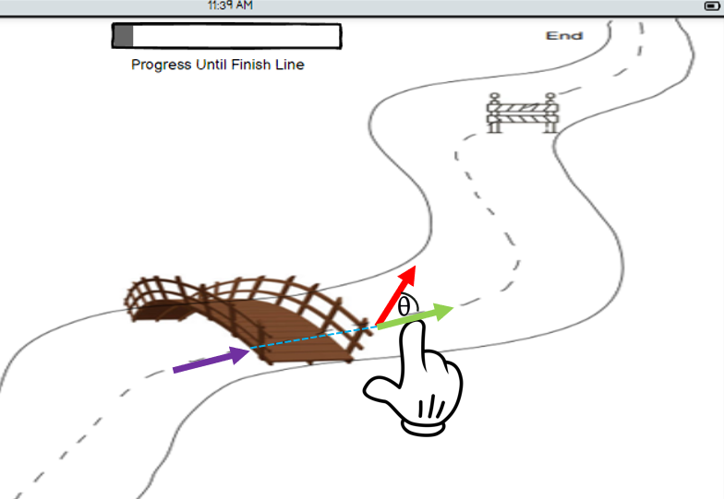
Figure 6: Visual example of an artificial directional deviation error generated by the system. We can see that the car came out of the blind spot in a different direction from the one beforehand. The red vector denotes the current (and wrong) direction of the car, and the green vector denotes the correct direction to which the user must correct the direction of the car. The angle between the said vectors, the ‘size’ or ‘severity’ of the error is the angle Θ (Theta).
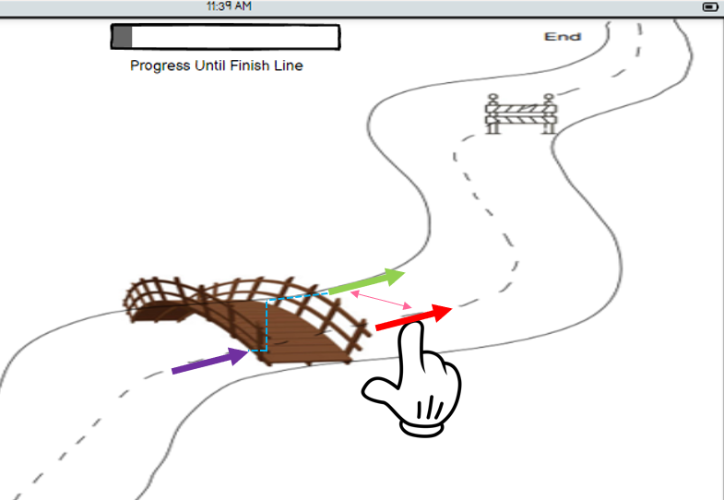
Figure 7: Visual example of an artificial locational deviation error generated by the system. We can see that the car came out of the blind spot in a different location from the one it entered it. The red vector denotes the current (and wrong) location of the user’s finger, and the green vector denotes the location of the car on screen. The user must correct the error by moving his finger to the location of the car when continuing to move across the course. The distance between the green and red vectors, the ‘size’ or ‘severity’ of the error is the Euclidian distance between them.

Definition of User Errors and Mistakes:
We consider a mistake, or an error made by the user when said user does not correct the deviation we generated. E.g., for Directional Errors [Fig 6], the test subject will continue to move the car in the same direction (angle) after the deviation instead of correcting the angle to the one (or close) to the angle prior to the deviation.
For Locational Errors [Fig 7], the test subject’s finger will remain in the location or path (coordinates on screen) of the car before it went into the blind spot (i.e., bridge/tunnel), and not from the location it came out of it.
We will test and monitor the detection of errors (if the user realized he made an error) by analyzing the velocity and displacement vector of the car after the deviations we have created. That is, after creating a directional deviation the user did or did not change his direction to the direction prior to our deviation. We will also calculate and analyze various kinematic metrics [paragraph 2.8].
Generating artificial errors and mistakes will allow us to test and understand the extent of the user's ability to detect and correct their errors.

5. Product
Our product is an interactive mobile app that will help collect and analyze data from test subjects. Each subject will perform a task and our app will collect the relevant data to analyze and present to the researcher.
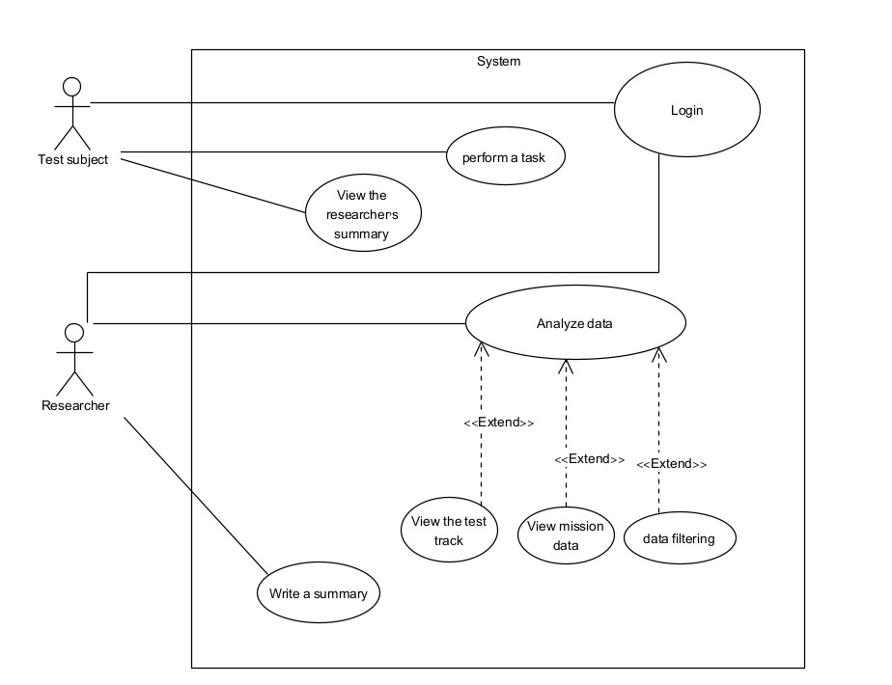
Figure 8: Use Case Diagram

5.1 Development Environment
We will develop our tool as an Android OS mobile app in Android Studio which is the official IDE and mobile development environment for android devices, built and maintained by Google with collaboration with JetBrains. The app is designed to run on Tablets and interaction with it will be via Touch Screen Actions. The code will be implemented in Java.

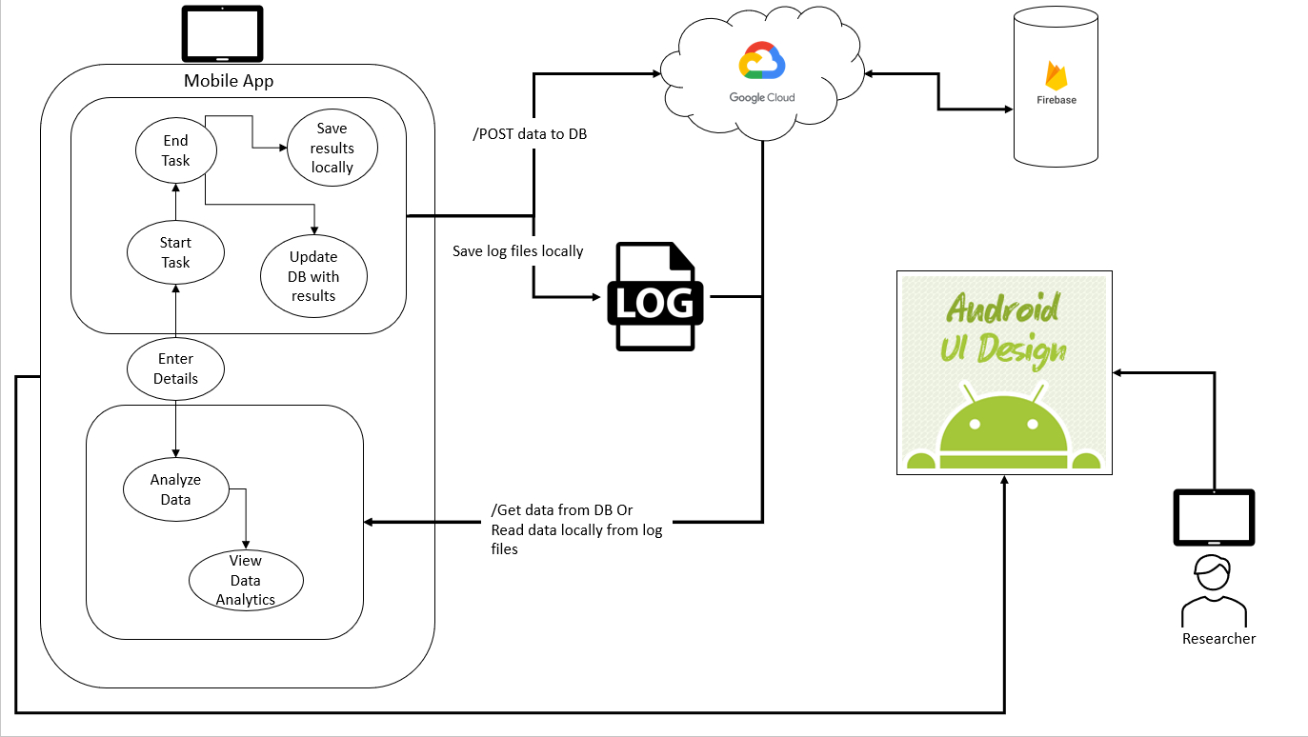
Figure 9: Architecture Flow diagram

5.2 Database
The data that we collect during the use of the application will be saved in the cloud in a database called Firebase and locally in the tablet device to allow the use of the application even without an internet connection.
Firebase is a cloud-based NoSQL database service provided by Google and stored in Google Cloud. It follows a JSON data model and provides a simple yet powerful API for data manipulation.

5.3 Log Files
Our system will automatically log relevant data and information which will be split into two different log files:
- System Log – In this file we will log all the information that belongs to the general flow and runtime of the system. Information such as Connection status to the DB or internet, errors or exceptions that occurred throughout the runtime, user interactions with the app (buttons that were pressed, finger pressure on the screen, etc.)
- User Data Log – In this file we will log and save all the data and information from the user while he executes the task. Data such as Timestamps and (x, y) coordinates. We will also divide the screen into segments which will help us analyze and process the data collected.

5.4 Analysis of Results
After collecting the data, we will use the Median Filter Algorithm to smooth the results and reduce unwanted noises.
We will calculate the displacement (position), velocity, and acceleration vectors using said data.
Let us denote the starting time, velocity, and position in the task as:
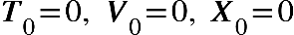
In any given time, we will calculate:
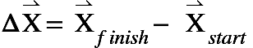
Formula 1: Displacement Vector calculation, it is a vector whose length is the shortest distance from initial and final position of a point undergoing motion. For any final position $x_{finish}$ and initial position $x_{start}$ the displacement vector is defined as the difference between said positions.
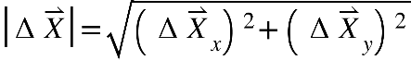
Formula 2: Magnitude of the displacement vector = length of the shortest distance.
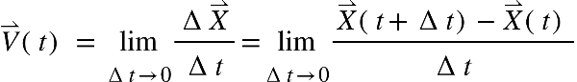

Formula 3: Instantaneous Velocity of an object calculated as the derivative, 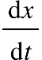, of the position (displacement) with respect to time.
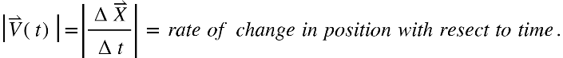

Formula 4: The magnitude of the instantaneous velocity, called Instantaneous Speed refers to the distance covered per unit of time at some instant in time.
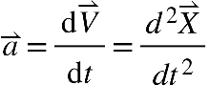

Formula 5: The acceleration vector refers to the rate of change of the velocity of an object with respect to time.

According to the velocity vectors in each screen segment (before, during, and after an artificial error [paragraph 4.2]) we could research and analyze the post-error slowing phenomenon.
We will also calculate the angles between the displacement vectors for analyzing the motion smoothness of the user, and again before, during, and after an artificial error [paragraph 4.2]).
The angle between two vectors:
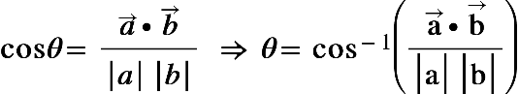

Formula 6: Calculating the angle between two given vectors.
Using the displacement vectors and the angles between them we can analyze and study the ability of the subjects to detect the errors they did (artificial errors that we caused [paragraph 4.2]) and the detection threshold (how sharp was the angle before and after an artificial error, after how much time did the angle/displacement change, etc.)

6. GUI
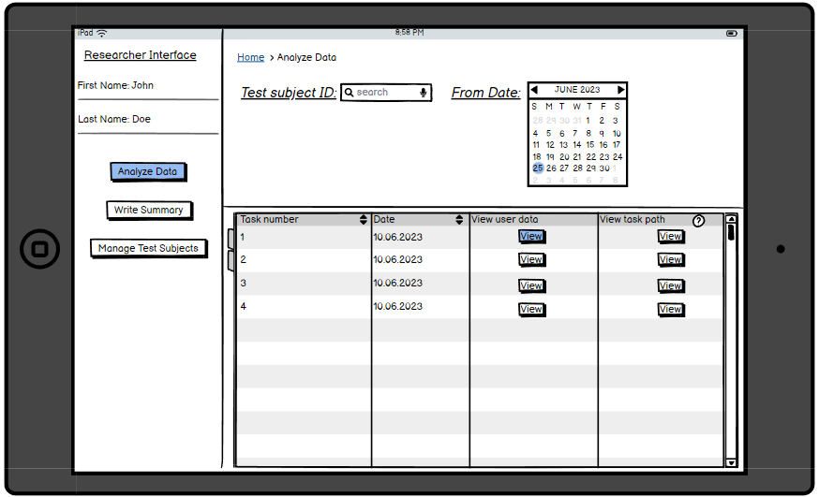
Figure 10: The GUI is divided to two parts: Researcher Screens, and Test Subject Screens. For the researchers, there will be 2 main windows that will help him navigate through our application and all the options available in it. This is the screen presented once opening the app in researcher mode.

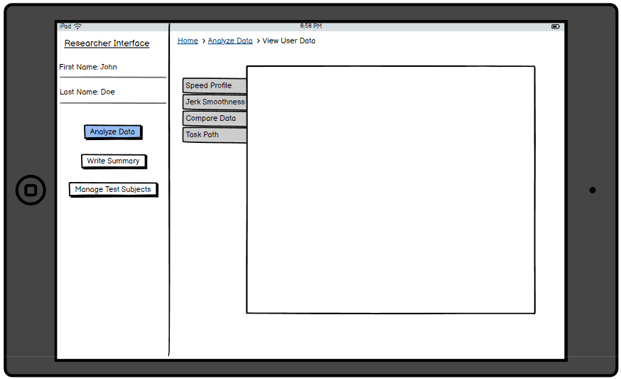
Figure 11: In this screen you can select which data would you like to view.

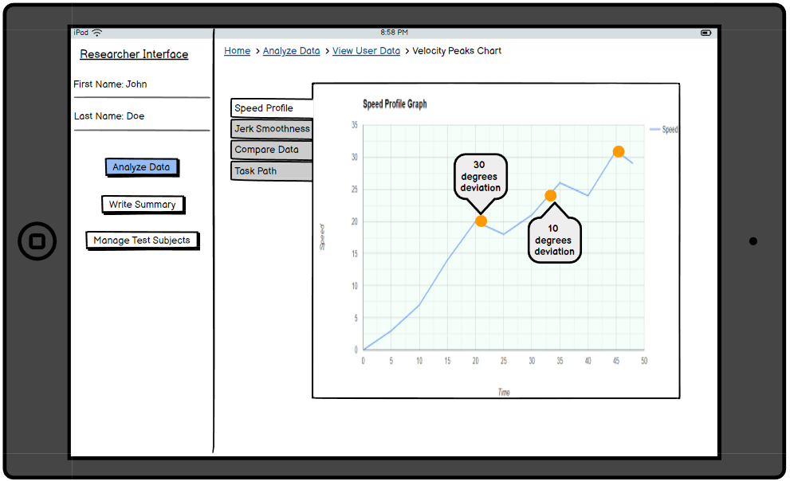
Figure 12: An example of how velocity profiles will be presented. In this screen the speed of the test subject throughout the task is showed, and the points in time which he encountered artificial errors are marked.
E.g., We can see that at 21 seconds the test subject encountered an artificial angle deviation error with size of 30 degrees, and after that deviation he slowed down. But at 10 degrees deviation he sped up so we can assume he didn’t notice the error.

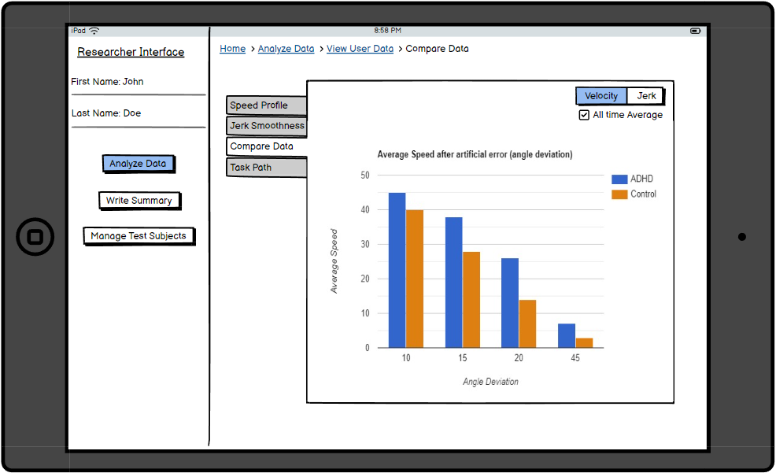
Figure 13: In this screen you can compare data between different tasks performed by the user or between an all-time average of all tasks saved in the database or only the tasks performed by specific test subjects. In this example we see a bar chart diagram presenting the average speed (Y Axis) of each test group (ADHD and Control) after encountering an angle deviation error (X Axis). The faster the speed, the faster the test subjects in that control group responded to an error and corrected it.

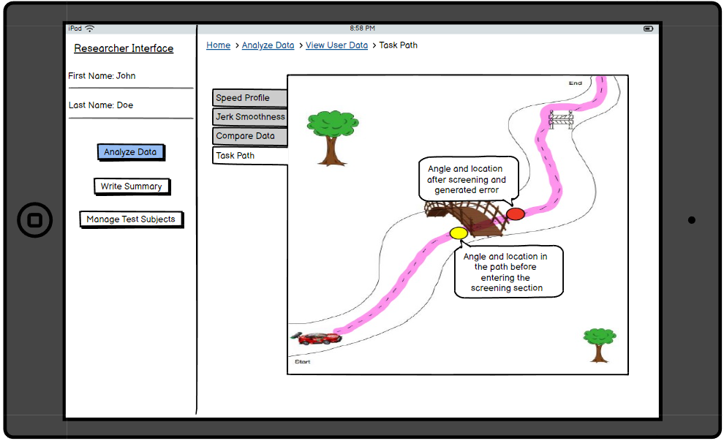
Figure 14: In this screen you can view the path that the user did throughout the task. The pink outline is the path which the test subject had moved the car/finger on screen. Key points are presented on screen and are clickable. Once clicked relevant data will be presented such as the angle of the car/finger, the location on screen, etc.

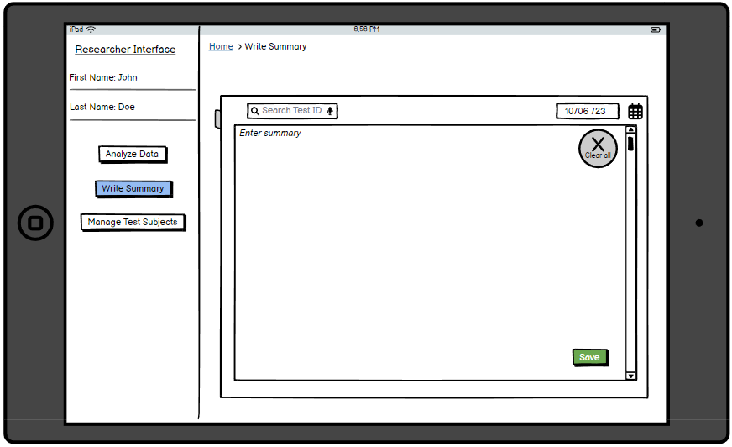
Figure 15: In this screen you can write a summary/diagnosis about the task performance and data analyzed.

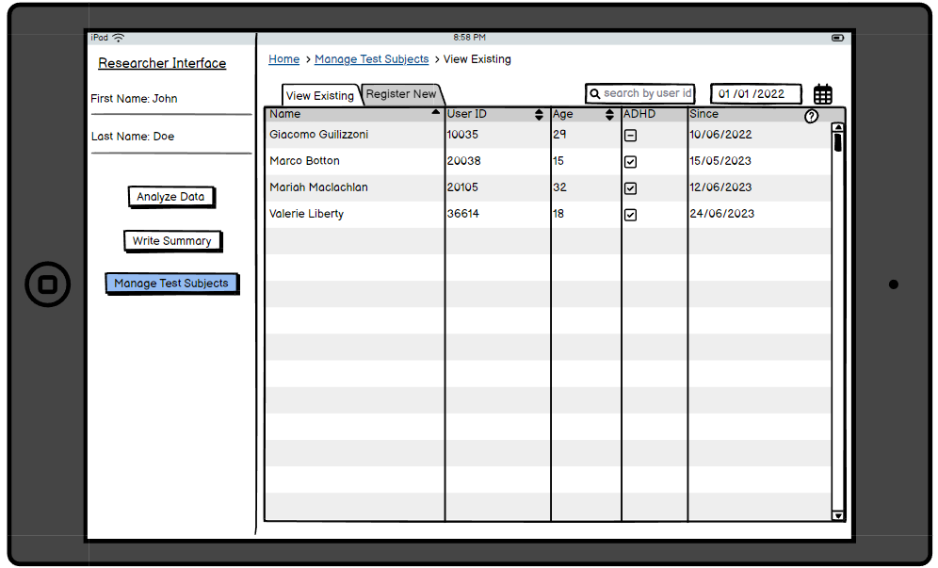
Figure 16: In this screen the researchers may view their test subjects.

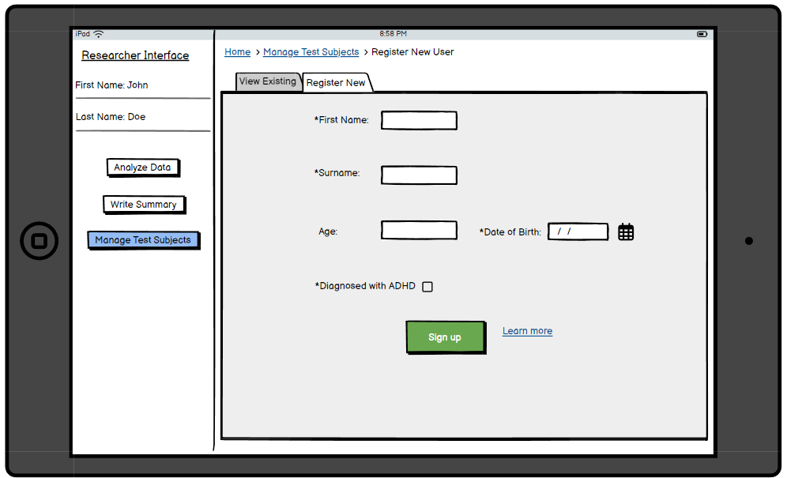
Figure 17: In this screen the researchers can register new test subjects and save them in the system.

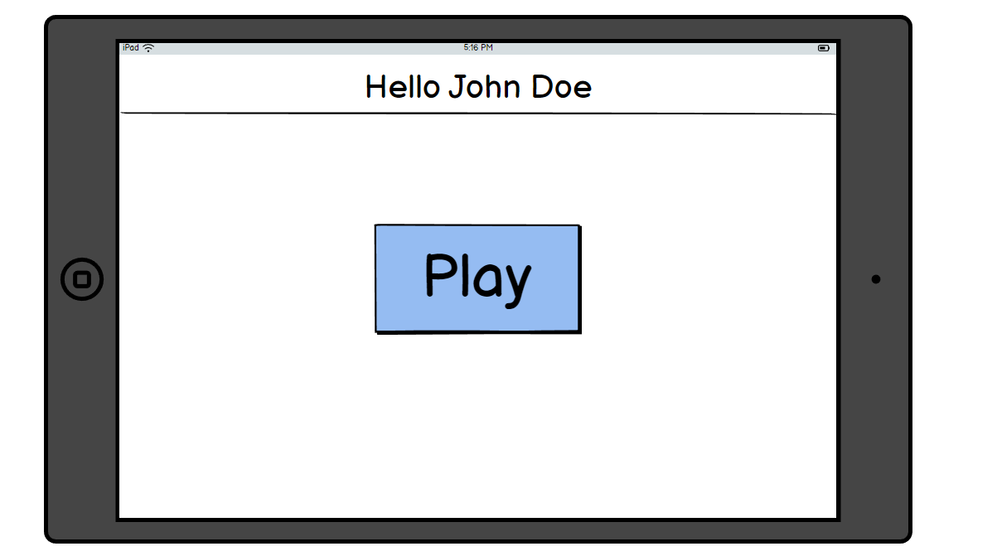
Figure 18: This is the screen the test subject will see when opening the app. A single button that will begin the task (the game) is presented.

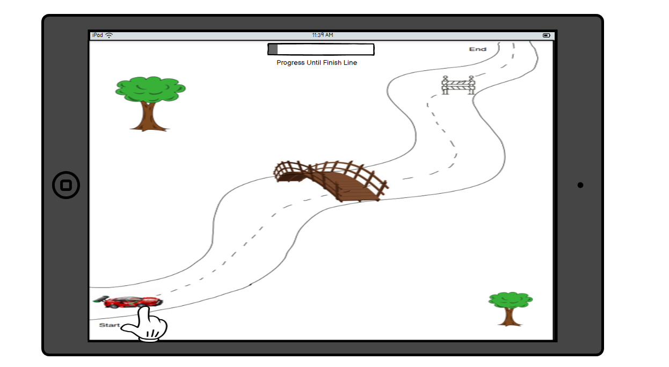
Figure 19: This is the task screen. The user is performing the task in this screen. A car will be presented at the starting point, and the user will move the car using his finger along the track.

7. Evaluation/Verification Plan

7.1 Evaluation
We will evaluate our application based on its ability to properly collect and analyze the data, in addition to testing the functionality of the system.
Our goal is to provide a tool that will be able to collect and analyze data as accurately as possible on the user's motor behavior with artificial errors.
We expect the system to find a correlation between the user's diagnosis (with and without ADHD) and the extent of the post error slowing phenomenon.

7.2 Verification-Testing plan
The testing plan for our application would involve several key components to ensure comprehensive data collection and analysis.
it would implement touch event listeners to capture precise touch coordinates, duration, and pressure applied during the motor task. These data points would be logged and stored for further analysis.
The testing program will also check the general functionality of the system such as the correct presentation of screens and response to buttons, the errors generated for the user, the correctness of the values received, and the correctness of the calculations performed on the collected data.
We will conduct the following tests to check our system:
functionality of the various screens and buttons
testing the kinematic metrics, movement recording when interacting with the app and task, performance, and stability of our calculations.
In addition, we will run various simulations on the system to check we receive normal data in case of accelerated and decelerated movement, smoother and less movement, and fast and slow movement.
When designing our system, we also need to decide on the task we will present to the users, specifically we need to design the task in such a way that we will get the best results and data.
The first phase will be a ‘pilot’ of our system with 5 test subjects. We shall examine the data collected and the user experience from feedback received, and adjust the task with consideration to various key aspects:
How many times will the user perform the task, and at what intervals?
How many artificial errors will be in the task?
Do the number of errors change for each time the task is repeated?
How winding / long the route of the task will be?
We will try to answer the above questions using a larger dataset of test subjects. Our second testing and adjusting phase will include 2 testing groups at the ages of 18-30:
ADHD group – 20 test subjects diagnosed with ADHD.
Control group – 20 test subjects without ADHD.
Several iterations of the second testing phase will take place, and we will make the proper adjustments for each iteration.
No. | Test description | Expected result
1 | System login check - registered/unregistered user | Registered- user's main screen.  Unregistered- error message
2 | Pressing a certain button | A suitable window will be shown
3 | “View data” of some test subject before he performed a task | Error message - "No data to display"
4 | Touch event listeners are properly registered and respond to finger movements on the screen | The car moves according to the finger movements
5 | Touch event listeners accurately capture touch coordinates during the motor task | Getting correct coordinate values
6 | Touch event listeners record the duration of the finger movement accurately | Getting the correct picture of the route taken
7 | Test the accuracy of the finger movements based on target positions or predefined paths. | Accuracy > 90%
8 | Checking the kinematic calculations (position, speed, acceleration) that the system does by sending predetermined values | An expected result is obtained
9 | Data filtering test | The data presented correspond to the filtering done
10 | Checking the time data received – time stamps that correlates to the (x, y) coordinates | Correct values were displayed
11 | Error threshold test - ignoring errors that the system creates | The system will produce larger errors
12 | Testing that the system accurately identifies the start and end point of the finger movement according to predefined points | Correct values were displayed

REFERENCES
[1] Notebaert, W., Houtman, F., Van Opstal, F., Gevers, W., Fias, W., & Verguts, T. (2009). Post-error slowing: an orienting account. Cognition, 111(2), 275-279.‏
[2] Botvinick, M. M., Braver, T. S., Barch, D. M., Carter, C. S., & Cohen, J. D. (2001). Conflict monitoring and cognitive control. Psychological review, 108(3), 624.‏
[3] MacLeod, C. M. (2005). The Stroop Task in Cognitive Research.‏
[4] Verbruggen, F., Notebaert, W., Liefooghe, B., & Vandierendonck, A. (2006). Stimulus-and response-conflict-induced cognitive control in the flanker task. Psychonomic Bulletin & Review, 13, 328-333.‏
[5] Danielmeier, C., Eichele, T., Forstmann, B. U., Tittgemeyer, M., & Ullsperger, M. (2011). Posterior medial frontal cortex activity predicts post-error adaptations in task-related visual and motor areas. Journal of Neuroscience, 31(5), 1780-1789.
[6] Christensen, K. E., & Lundwall, R. A. (2018). Errors on a computer task and subclinical symptoms of attention‐deficit/hyperactivity disorder (ADHD). Scandinavian journal of psychology, 59(5), 511-517.‏
[7] Schachar, R. J., Chen, S., Logan, G. D., Ornstein, T. J., Crosbie, J., Ickowicz, A., & Pakulak, A. (2004). Evidence for an error monitoring deficit in attention deficit hyperactivity disorder. Journal of abnormal child psychology, 32, 285-293.‏
[8] Botvinick, M. M., Cohen, J. D., & Carter, C. S. (2004). Conflict monitoring and anterior cingulate cortex: an update. Trends in cognitive sciences, 8(12), 539-546.‏‏
[9] https://www.mayoclinic.org/tests-procedures/eeg/about/pac-20393875
[10] Dörner, D., & Schaub, H. (1994). Errors in planning and decision‐making and the nature of human information processing. Applied psychology, 43(4), 433-453.‏
[11] Falkenstein, M., Hoormann, J., Christ, S., & Hohnsbein, J. (2000). ERP components on reaction errors and their functional significance: a tutorial. Biological psychology, 51(2-3), 87-107.‏
[12] American Psychiatric Association. (2015). Neurodevelopmental disorders: DSM-5® selections. American Psychiatric Pub.‏
[13] An, K. N. (1984). Kinematic analysis of human movement. Annals of biomedical engineering, 12, 585-597.‏.‏
[14] de los Reyes-Guzmán, A., Dimbwadyo-Terrer, I., Trincado-Alonso, F., Monasterio-Huelin, F., Torricelli, D., & Gil-Agudo, A. (2014). Quantitative assessment based on kinematic measures of functional impairments during upper extremity movements: A review. Clinical Biomechanics, 29(7), 719-727.‏
[15] Dahan, A., & Reiner, M. (2017). Evidence for deficient motor planning in ADHD. Scientific reports, 7(1), 1-10.‏

